GENI Lab 7 (10 points), 11/1/2018

Name: Savon Jackson

Student #: 870423569

Login to nodes:

Host A login: savojack@pc1.geni.it.cornell.edu –p25442

Host B login: savojack@pc1.geni.it.cornell.edu –p 25443

Host C login: savojack@pc1.geni.it.cornell.edu -p25444

Host D login: savojack@pc1.geni.it.cornell.edu -p25445

Answer the following questions from “GENI-lab7-Instruction”

Lab Details, Part I: Router Interface. (3 points)

Screenshots of all four terminals after running vtysh: each screenshot should include the two commands of show ip ospf neighbor and show ip ospf route. (The following is a sample.)

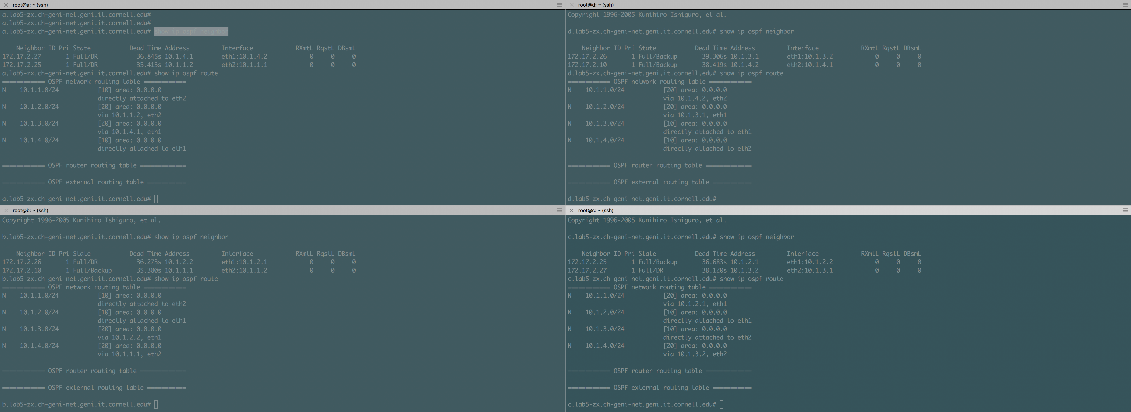

Host A

Host C

Host D

Host B

**Your screenshots here:**

Node A

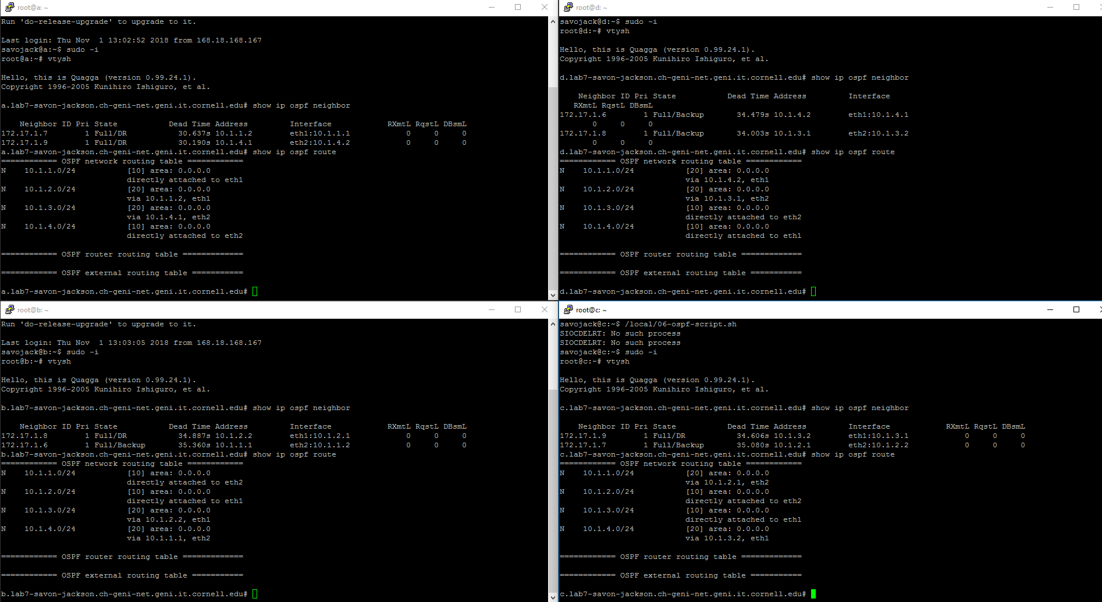

Lab Details, Part II: Dead Link. (3 points)

Screenshots of terminal A and terminal D. (The following is a sample.)

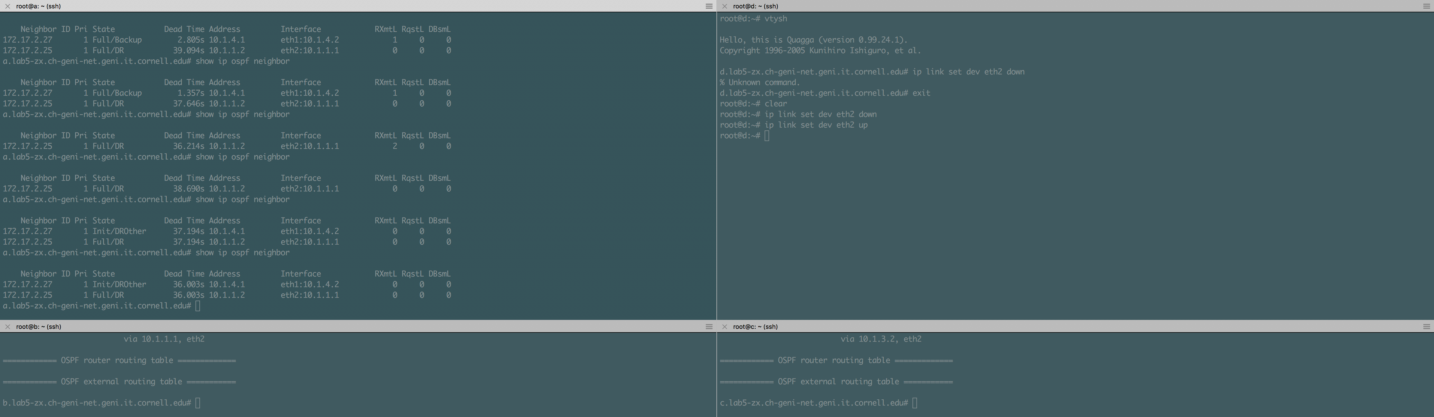

D is a neighbor, again.

D is no longer a neighbor.

D is a neighbor.

**Your screenshots here:**

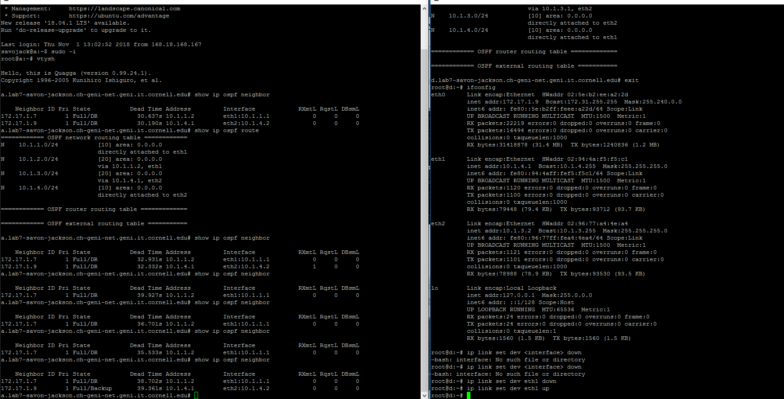

Lab Details, Part III: Route Change. (4 points)

Screenshots of the **two terminals to nodes a and d** where you experimented with the commands of traceroute and ip. (The following is a sample.)

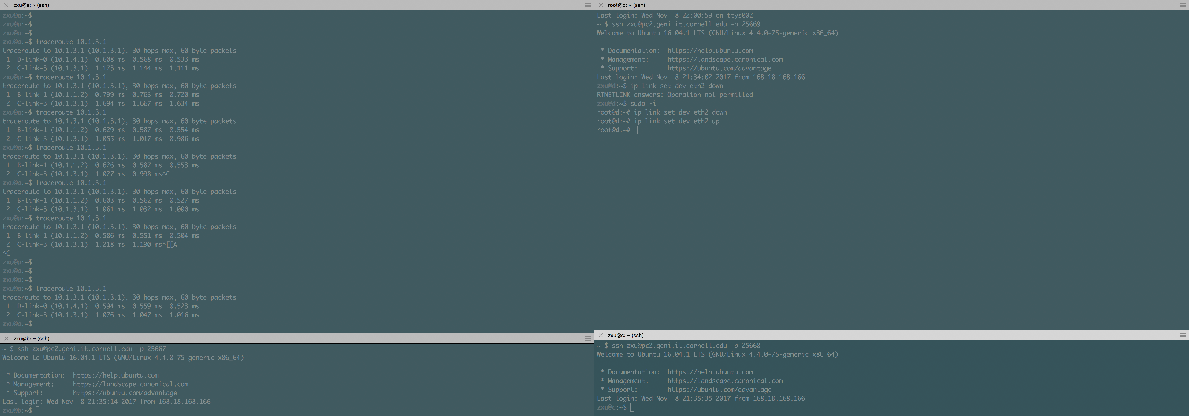

Back to A -> D - > C

Change to A -> B - > C

A -> D - > C

**Your screenshots here:**

